**Brooklyn torah gazette**

**For parshas chukas-balak 5780**

Volume 4, Issue 39 (Whole Number 191) 12 Tammuz 5780/ July 4, 2020

**Printed L’illuy nishmas Nechama bas R’ Noach, a”h**

**My Baby Brother**

**Was Not Forgotten**

**By Rabbi** [**Mendy Kaminker**](https://www.chabad.org/search/keyword_cdo/kid/12111/jewish/Kaminker-Mendy.htm)

[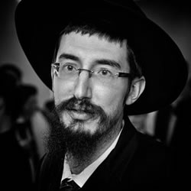](https://www.chabad.org/search/keyword.aspx?kid=12111)

“Are there any other children?” The [Lubavitcher] Rebbe asked, as he was about to enter 770 Eastern Parkway (the Chabad-Lubavitch World Headquarters).

“No,” my mother replied.

“No more children?” the Rebbe asked again.

“No,” my mother replied again.

The Rebbe motioned with his hand as if to say, “Something appears to be amiss.”

And then my mother finally realized that she had overlooked my seven-month-old brother blissfully asleep in his stroller nearby.

It was the winter of 1987. My family had traveled from Israel to Brooklyn, to spend three weeks with the Rebbe.

For decades, when the Rebbe would enter or exit 770, he’d often reach into his pocket and lovingly hand a coin to every single child for him or her to place into the charity box.

You can imagine the excitement of the children who received a coin from the Rebbe himself!

As guests from Israel, we used every opportunity to receive coins for charity from the Rebbe and be in his holy presence.

During one of those moments, we stood together with another family waiting for the Rebbe to enter 770.

The Rebbe pressed a coin into each of our little hands, and when he finished he looked at my mother and asked in Yiddish:

“*S’iz faran noch kinder?*” (Are there any other children)?

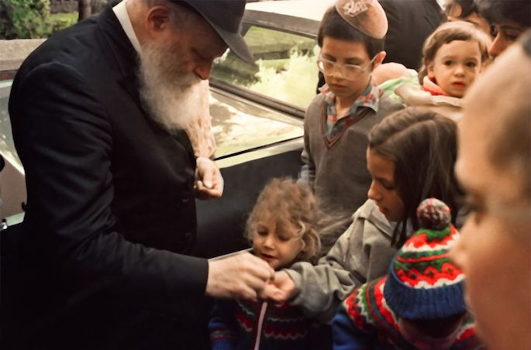

**The Lubavitcher Rebbe, zt”l, giving coins to children for tzedakah (charity).**

My mother, awed by the encounter with the Rebbe, forgot about her baby sleeping nearby.

She might have forgotten. But the Rebbe? The Rebbe didn’t forget.

Some 25 years earlier the Rebbe [shared a story](https://www.chabad.org/therebbe/letters/default_cdo/aid/1883425/jewish/A-Childs-Cry.htm) about the First Chabad Rebbe, Rabbi Shneur Zalman of Liadi, and his son, Rabbi Dovber:

“Rabbi Dov Ber was known for his unusual power of concentration. When he was engaged in study or prayer he was totally oblivious to everything around him.

“On one occasion, when Rabbi Dov Ber was thus engrossed, his baby sleeping in a nearby cot fell out of his cradle and began to cry. Rabbi Dov Ber did not hear the baby’s cries.

**The Infant’s Grandfather Heard the Baby’s Cries**

“The infant’s grandfather, the Old Rebbe, who was in his study on the upper floor also engrossed in his studies, did hear the baby’s cries. He interrupted his studies, went downstairs, lifted the infant, soothed it and replaced it in its cradle. To all this, the infant’s father remained quite oblivious.

“Subsequently, the Old Rebbe admonished his son: ‘No matter how engrossed one may be in the most lofty occupation, one must never remain insensitive to the cry of a child.’

“This story is transmitted to us from generation to generation for the lasting message which it conveys. In fact, it came to characterize one of the basic tenets of the Chabad-Lubavitch movement—to hearken to the cry of a child.

“The ‘child’ may be an infant in age, a minor or teenager, a Jewish boy or girl attending public school, fallen from the ‘cradle’ of the Jewish religion, heritage and way of life.

“Or it may be an adult in years, yet an ‘infant’ with regard to knowledge and experience of the Jewish religion and heritage and way of life, as so many Jewish students on the campuses of colleges and universities, or other walks of life.

**The Souls of these Jewish ‘Children’ Cry Out in Anguish**

“The souls of these Jewish ‘children’ cry out in anguish, for they live in a spiritual void. They cry out for a guiding hand that would restore to them the security and warmth and comfort of their faith, and give meaning to their empty lives, whether they are conscious of it, or feel it only subconsciously.

“We must hear their cries, no matter how preoccupied we may be with any lofty cause, for to help them back to their Jewish ‘cradle’ takes priority over all else.

“Humanity as a whole seems to have fallen out of its ‘cradle’ too, crying out in fear of nuclear self-destruction, threatened to be engulfed by the dark forces of G‑dlessness and demoralization. Only a return to G‑d and to the Divine Laws of justice and morality can restore peace and security to the human race.

“No one must be so wrapped up in himself as to remain insensitive to the situation around him. Everyone can do something in his own way, beginning with himself, his family and neighborhood. In the final analysis, the whole world is like one organism which, if sick in one part or limb, is sick all over; while contributing to the wholesomeness of one part contributes to the well-being of the whole.”

On that winter day in 1987, my family experienced first-hand the Rebbe’s attentiveness - not only to the crying child, but to the child quietly asleep, too.

Last week we commemorated the Rebbe’s [26th] *yahrzeit*.

I believe that the most appropriate way to honor the Rebbe on this special day is by following his example.

We all know children of every age, some crying, and some maybe even fast asleep with no one paying them heed, but all longing for connection (and may I suggest that deep inside we all have our internal crying and sleeping children?).

We need to hug the child. To show him and her love. To help them foster a loving, fulfilling relationship with G‑d that will last a lifetime.

As the Rebbe taught us, we need to listen to their cry - and perhaps even more importantly, to be mindful of them when they are silent.

*Reprinted from the Parshat Korach 5780 email of Chabad.Org Magazine.*

**Rabbi Berel Wein on**

**Parshat Chukat**

The Jewish people find themselves in great difficulty after the death of the prophetess Miriam. Her miraculous well had sustained them with water during their long sojourn in the desert of Sinai. And now that she was no longer alive, this water, so identified with her being, also disappeared from their midst.

They complain to Moshe and clamored for water. People can go on for days without solid food but not without water, especially in a desert. Moshe strikes the rock instead of speaking to it, as he was instructed to do, but water flows miraculously in abundance from the rock, and the situation is stabilized.

There will be sad consequences for Moshe from this incident, but apparently the people are not subject to punishment for their demands to Moshe that he provide them with water, which precipitated the entire matter. In fact, the people will break into song and poetry over this new well of blessed water.

Yet, we find that when the people requested meat, the meat miraculously arrived, but the people were severely punished for their request. It seems that requesting and even demanding water, a necessity of life for human existence, is permissible. However, demanding meat, which is a luxury food is inappropriate. There is a great lesson for all of us in this matter. Demanding and even praying for more than we really need and are entitled to carries with it the seeds of subsequent problems and even disaster.

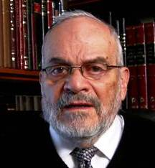

Chassidic legend and tradition records a discussion between Rav Yitzchak Vorker and Rav Menachem Mendel Morgenstern, the Kotzker Rebbe, regarding why the Jewish people escaped immediate punishment for the sin of the Golden Calf, while for the sin of the Spies and their rejection of entering the land of Israel, the punishment was immediate and harsh.

The Vorker Rebbe explained that when the Jewish people repented after the sin of the Golden Calf they were yet unaware that repentance could nullify decrees and punishment. Nevertheless, they repented sincerely without expectations of forgiveness, and their repentance was accepted. After the sin of the spies, they already knew that repentance could bring about forgiveness, so their repentance was insufficiently sincere.

The Kotzker Rebbe thought otherwise. He said that the sin of the Golden Calf had in it the seeds of searching for and serving a higher power. They went about it incorrectly, but there was a spark of holiness in their quest for divinity. However, the sin of the spies was of a different nature. Its motivation was that they wished for an easy life of luxuries, without the challenges that a nation-state automatically inflicts on its inhabitants.

Such a base motive was unacceptable to Heaven. We pray for health and prosperity to be able to serve G-d with more sincerity and more effectively*.*If we pray only out of selfish motives, then we have missed the mark with our prayers. This week’s Torah reading is a powerful reminder of this truth.

*Reprinted from this week’s website of Rabbiwein.com*

**Parshas Chukas**

**The Extent of Reward**

By Rabbi Bentzion Shafier

Founder of TheSmuz.com



HASHEM said to Moshe, “Do not fear him, for into your hands have I given him, his entire people, and his land; you shall do to him as you did to Sichon, king of Amori, who dwells in Cheshbon.” — Bemidbar 21:34

The Jewish nation had just defeated the Emorim and were preparing to conquer Bashan. Og, the king of Bashan, led his army out to meet the Jews in battle. Og was a giant of a man and was feared amongst the nations and Moshe Rabbeinu was reluctant to attack. HASHEM reassured him, saying, “Do not fear him.”

Rashi explains that Moshe was not afraid of Og because of his physical stature, but because of his personal merit. Many years earlier, in the time of Avraham Avinu, a coalition of five kings ruled the world. Four competing kings joined forces and waged war against these five kings and were victorious.

During one of the battles, they captured Sedom, where Avraham’s nephew Lot had been living. Og survived that battle and ran to Avraham to tell him that Lot was being held captive. Because Og did this favor for Avraham, Moshe was afraid that the merit of that act would allow Og to beat the Jews in battle.

This Rashi is very difficult to understand, as the Midrash also explains Og’s motivation. Sarah Imeinu was one of the four most beautiful women who ever lived. For many years, Og had his eye on Sarah. The problem was that she was a married woman.

With the capture of Lot, Og saw his moment. His plan was simple. He would tell Avraham that his nephew had been captured. Avraham, the altruistic tzaddik, would go to save his nephew. The four kings, the most powerful force on earth, would never allow a captive to go free. Avraham would enter into battle with them and be killed. And along would come the gallant Og to save Sarah from her widowhood. With this plan in mind, Og arrived to tell Avraham the news.

Og wasn’t engaged in redeeming a captive; he was manipulating events to cause the death of an innocent man in hopes of taking his wife. Why would Moshe be afraid of the merit of such an act? That act wasn’t a mitzvah. If anything, it was a sin.

The answer to this can best be understood with a mashal.

**What is Your Grade Point Average?**

What’s your GPA?

Imagine that a recent college graduate applies for a job, and the interviewer asks him about his academic record. “So tell me, how did you do in school?” “Well, my first semester, I got an A in Chemistry, a B in Accounting, and a B+ in Economics. The next semester, I got…” “Okay, okay,” the interviewer says. “You don’t need to give me every detail. Just tell me your overall grade point average”

The employer doesn’t want to know the minutiae. He’s just looking for an overview. He wants to know in general terms whether or not this fellow is intelligent and hard-working. To find out, he asks for the cumulative average.

One of the reasons we don’t fear being judged at the end of our lives is that we assume that the judgment will be like a GPA, an average of everything that we’ve done. “I’m not afraid because, on balance, I was a good guy. I’m not saying I was a tzaddik. I’m not saying I was perfect. But I did a lot of good things, accomplished plenty. Granted, I could have done more. Certainly there were some things I should not have done. But overall, I’m okay.”

**Every Act is Judged Separately**

The Mesillas Yesharim (Chapter 4) explains that in the World to Come, the judgment isn’t “on balance.” Every act is judged separately. For every act that was meritorious, I will be rewarded. For every act that I should not have committed, I will be punished. But one doesn’t cancel out the other. My mitzvos don’t wipe away my aveiros, and my sins don’t eliminate my mitzvos.

Each one is weighed and measured, and rewarded or punished independently. Furthermore, just as each action is weighed separately, so to is each part of the action. If I volunteered to drive an elderly man to a doctor’s appointment, on one hand it is a great act. I took off an entire afternoon to help a fellow Jew. For that, I will be rewarded. But what if while driving, I couldn’t help but feel a twinge of arrogance thinking, “Look at me. How many people are as good as I am? Come on, how many people selflessly, without any drive for honor, help an old man? Not many…”

**It the Act a Mitzvah or an Aveirah?**

So is this a mitzvah or an aveirah? The answer is both. The outer act was great. But the inner condition was flawed. For the act, I will be rewarded. The self-inflation, however, damaged me, and for that I need atonement. Each part weighs into the verdict.

This judgment is very different than the way we assess things in this world. When we judge others, we focus on their intention. Was he trying to help me or to harm me? Is he a friend or foe? HASHEM’s ruling, however, is infinitely more exacting.

There are many dimensions to each act, and many factors to be considered. What were your motives? How pure were they? Where were you coming from? Was this easy for you or difficult? Each act is judged separately, and each part of the act is broken down as well.

Was the act a mitzvah or a sin?

This seems to be the answer to Og. Og was plotting an act of murder. But he was instrumental in saving Avraham’s nephew. While his intention was evil, the act had merit; it helped a tzaddik. The precision of judgment is so great that nothing is overlooked. In most situations, an act like this, which was so devoid of purity, would have little weight. But this was the great Avraham that he had assisted.

**A Favor that Has Considerable Merit**

A favor to such a man, albeit a favor extremely damaged, has considerable merit. Moshe was afraid because the Jewish nation was entering into war, and war is a time of danger. In a time of danger, the sins of the people might be revisited, and the fate of the nation might be re-examined to determine whether they deserved a miraculous victory. In such a calculation, Og’s merit might tip the scale.

This concept is very illustrating. By seeing the extent of judgment, we come to understand the greatness of man. We recognize how significant our actions are and how great an impact they have on us and on the world.

*Reprinted from this week’s website on TheShmuz.com This is an excerpt from the [Shmuz on the Parsha book](https://theshmuz.com/product/shmuz-on-the-parsha-book/).*

**The Connection of Bilaam**

**And the Coming of Moshiach**

From the Talks of the Lubavitcher Rebbe

Rabbi Menachem Mendel Schneerson, Zt”l

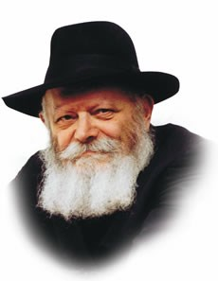

Of all the prophecies in Scripture that refer to the Messianic era, the one contained in this week's Torah portion, Balak, is most unusual in that it came from Bilaam, a gentile prophet.

Bilaam, the foremost prophet of his time, was forced against his will to foretell the downfall of the nations of the world and the ultimate ascendancy of the Jewish people.

The very fact that this prophecy is included in our holy Torah indicates its special significance; indeed, it contains a distinct advantage precisely because it was said by a non-Jew.

For, when Moshiach comes, the Jewish people will no longer be subservient to the nations; on the contrary, the gentile leaders will vie with one another for the privilege of serving the Jews!

Thus, the prophecy of Bilaam concerning the Final Redemption not only gave the Children of Israel cause for rejoicing over their future, it actually afforded them a "taste" of the way things will be in the Messianic era.

As far as prophecy itself is concerned, our Sages foretold its reoccurrence among the Jewish people before Moshiach's arrival according to the following chronology:

Commenting on the verse in this week's Torah portion, "At the proper time shall it be said to Jacob and to Israel, what G-d has wrought," Maimonides noted that prophecy would return to Israel after "the proper time" had elapsed after Bilaam, i.e., after the same number of years as had passed since the creation of the world until his prophecy.

Bilaam's prophecy was said in the year 2488; 2488 years after that, in the year 4976 (we are now in the year 5755), prophecy was destined to return to the Jewish people.

In fact we find that this was indeed the case, for it was then that prophetic luminaries began to appear on the Jewish horizon - - Rabbi Shmuel Hanavi, Rabbi Elazar Baal "Harokeach," Nachmanides, the Ravad (Rabbi Abraham ben David), Rabbi Ezra Hanavi and Rabbi Yehuda the Chasid and others.

More generations passed until the birth of Rabbi Yisrael Baal Shem Tov, the founder of Chasidut, and his successor, the Magid of Mezeritch, about whom it was said that they "could see from one end of the world to the other."

The following generation produced Rabbi Shneur Zalman, who formulated Chabad Chasidut. Had he lived in the times of our prophets he would have been on a par with them; moreover, this chain of prophecy continued from one Chabad leader to the next, until the present day, when the Rebbe has prophesied that Moshiach's arrival is imminent.

The return of prophecy to the Jewish people is therefore both a prerequisite and preparation for the Messianic era, which is due to begin at any moment.

*Reprinted from the Parshat Korach 5755 edition of the Lubavitch Youth Organization. Adapted from Likutei Sichot of the Rebbe, Vol. 2*

**The Blind Spots**

**By Rabbi Joey Haber**

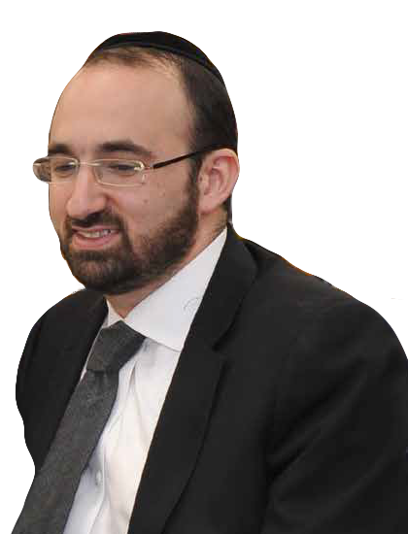

Parashat Hukat introduces us to the *mitzvah* of *parah adumah* – the special red cow that was used for purifying.  The cow was slaughtered and burned, and the ashes were then be mixed with water.  That water would be used to make somebody or something *tahor* (“pure”) after it had become *tameh* (“impure”) by coming in contact with a dead body.

The Midrash draws a connection between the *parah adumah* and the sin of the golden calf.  A calf is a young cow.  And so the *parah adumah* represents the “mother” of the golden calf.

**The Responsibility of the Mother**

In the words of the Midrash: *“Let the mother come and clean up her child’s mess.”*

When a young child makes a mess, the parent has the responsibility to clean up the mess.

Thus, the *parah adumah* serves to atone for the sin of golden calf – like a mother cleaning up the mess made by her child.

The Midrash implicitly conveys what might seem like an obvious message, but which is, unfortunately, not always as obvious as it should be:

***When there is a mess to clean up, we need to clean it up.***

I cannot tell you how many times I have heard parents of married children complain, “**CAN’T THEY AT LEAST CLEAN THE HIGHCHAIR?!!?!”**

Especially in the summertime, it is common for young couples to spend a lot of time in their parents’ houses, or even move in for a few weeks.  They need to be responsible, and, quite literally, *clean up the mess*.  It is not considerate to their parents to leave it to them to clean up the kids’ mess.  They need to take responsibility.

**A More General Lesson**

But there’s a more general lesson here, too.

  People are sometimes oblivious to their surroundings, to the “messes” that they make without taking care of, or taking responsibility for.  They go about their business doing what they want to do without showing any regard for what’s going on around them, for the “mess” that needs to cleaned up.

This happens because of selfishness – something that all of us have.  We are all selfish in some way.  And to an extent, this makes sense.  We all have personal needs that we need to care for.  The problem is that these needs create “blind spots” that shield our vision, that don’t allow us to see other people and their needs.  These “blind spots” prevent us sometimes from seeing the “mess” that we are making and that we are supposed to be “cleaning up.”

**The Solution**

The solution to this problem is to make a special effort to keep our eyes open and look around us.  We don’t need to live with blind spots.  If we turn our heads far enough, we’ll see more.  If we pay closer attention to the people around us, we won’t be blind to their needs.

So let’s try to always stay attuned to what’s going around us.  Let’s “clean the highchair.”  Let’s clean up the messes that we are responsible to clean up, and show greater concern and consideration for all the people in our lives – who will then, undoubtedly, do the same for us.

This will make our homes, our families and our community so much happier.

*Reprinted from this week’s iTorah.com website.*

**The Jewish Side of Bob Dylan**

**By Daniel Keren**

(Youtube – Bob Dylan, the Rabbi and Me – Louie Kemp and 50 Years of Adventures (1:08)



**1957, at Jewish summer camp: Bobby Zimmerman with guitar. Louie Kemp to his right.**

It was in 2016 that the world was somewhat surprised to learn that the Swedish Academy in Stockholm, Sweden has selected Bob Dylan (a.k.a. Bobby Zimmerman) for that year’s Nobel Prize for Literature. It was the first time that the world’s most prestigious literary honor had been given to a composer of songs, albeit the poet laureate of rock music whose songs like “Blowin’ in the Wind” and “Mr. Tambourine Man” helped influenced a generation of Baby Boomers more than a half century ago.

Many readers the Jewish Connection are aware of the fact that Bob Dylan is Jewish. A very interesting insight into that Jewish connection of one of the greatest American songwriters can be gained by viewing a recent video created and moderated by Rabbi Yossi Friedman (son of Rabbi Manis Friedman and brother of the singer Benny Friedman [and nephew of the singer Avram Fried].

The video posted on youtube is titled “Bob Dylan, the Rabbi and Me – Louie Kemp and 50 Years of Adventures.” It is based on a book published last August by Louie Kemp “Bob Dylan and Me: 50 Years of Adventure” by who first met Bobby Zimmerman as a fellow camper in Camp Herzl back in 1953 where they became lifelong friends.

Kemp’s book does mention many of the author’s shared Jewish connection with the future Bob Dylan the book is mostly focused on their personal friendship over a half century since meeting in that Jewish sleeping camp in Webster, Wisconsin. The author in an interview with the Times of Israel admits that he has not been in such close contact with the famed singer since 2001.

The youtube interview of Louie Kemp and Rabbi Manis Friedman by Rabbi Yossi Friedman, however, focuses entirely on the Jewish connection of both Bob Dylan and Louie Kemp. Rabbi Yossi Friedman grew up in St. Paul, Minnesota where his father [Rabbi Manis Friedman] has been since 1971 the dean of Bais Chana, a seminary for women coming from non-religious backgrounds. Currently Rabbi Yossi Friedman is the Program Director of Chabad of Alabama in Birmingham.

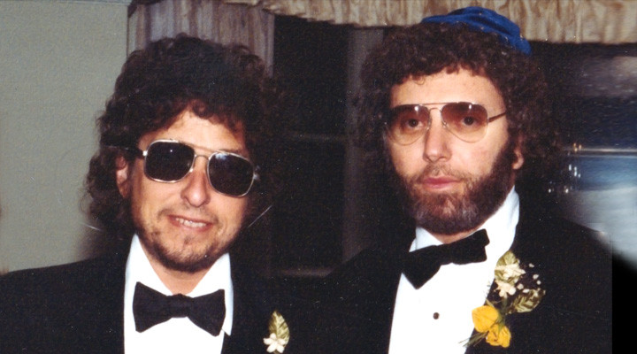

**1983: Bob Dylan (left) as the best man at Lou Kemp's wedding**

This video focuses on the memories of both Rabbi Manis Friedman and Louie Kemp on the pintele Yid (the Jewish connection) of Bob Dylan. Bobby Zimmerman was born in Hibbings, Minnesota which had a very small Jewish population. Louie Kemp was born in Duluth, Minnesota which had a larger but still very small Jewish community.

Another thing both Bob Dylan and Louie Kemp had in common was that they connected with Rabbi Friedman who is a popular kiruv rabbi who has travelled around the English-speaking world giving lectures on various aspects of Judaism and Yiddishkeit to audiences of varied religious backgrounds. Harpers Collins published in 1990 his book “Doesn’t Anyone Blush Anymore: Love, Intimacy and the Art of Marriage,” that became a best-seller in part on a positive plug from Mr. Dylan.

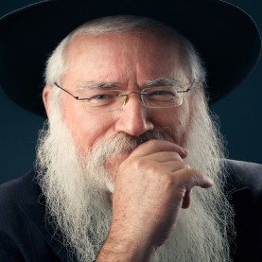 

**Rabbi Manis Friedman**

In the youtube video, Mr. Kemp recalls how despite his financial success, he somehow realized that there was more to life than material and physical pleasures. He called Rabbi Friedman out of the blue on a freezing cold winter evening and asked him to meet him at the airport where he was catching a flight from the Twin Cities to Duluth. In their brief encounter, Rabbi Friedman answered some of Louie’s questions on life and persuaded him to come back to talk about any other questions he still had.

That in turn set the stage for Louie Kemp to introduce his good friend Bob Dylan to Rabbi Friedman back in the 1980’s when Dylan was getting spiritually messed up by a group of Christian missionaries. Kemp bought Rabbi Friedman a ticket to Los Angeles and Bob Dylan immediately connected with the Chabad rabbi who gave him a new and exciting insight into Judaism. One shudders to think that had Rabbi Friedman not bothered to go out of his way to meet Mr. Kemp, two then assimilated Jews might have been lost forever.

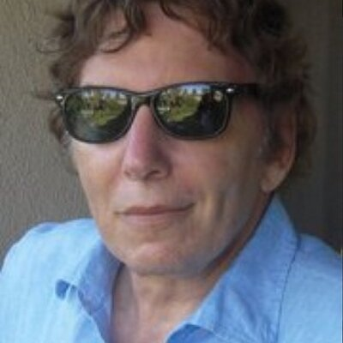 

**Louie Kemp today Louie Kemp’s new book on his friendship with Bob Dylan**

While Louie Kemp has become religious, Bob Dylan has also come to terms with his religious heritage in a more positive style, although it may not be on the same level as his old boyhood friend. If you have an hour and eight minutes to spare, you can’t go wrong by clicking this interesting youtube production – “Bob Dylan, the Rabbi and Louie Kemp.”

***Reprinted from the June 26, 2020 edition of the Jewish Connection.***

**Who Was Elisheva?**

**By**[**Menachem Posner**](https://www.chabad.org/search/keyword_cdo/kid/12145/jewish/Posner-Menachem.htm)

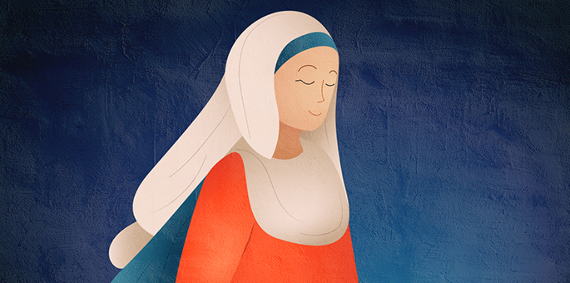

Elisheba (or more accurately, Elisheva) appears just once in the Torah, where we read:

And Aaron took to himself for a wife, **Elisheba**, the daughter of Amminadab, the sister of Nachshon, and she bore him Nadab and Abihu, Elazar and Ithamar.[1](javascript:doFootnote('1a4788775');)

The sages count the prominent and holy men in her family:[2](javascript:doFootnote('2a4788775');)

**She was married to**[**Aaron**](https://www.chabad.org/library/article_cdo/aid/4033914/jewish/Aaron-the-High-Priest.htm), the high High Priest, and was thus the mother of all kohanim (priests) from Biblical times until today.

**Her brother-in-law was**[**Moses**](https://www.chabad.org/library/article_cdo/aid/73398/jewish/Moses.htm), the greatest prophet to ever live.

**Her father was Aminadav**, whose lineage traces back to Peretz, son of Judah.[3](javascript:doFootnote('3a4788775');)

**Her brother was [Nachshon](https://www.chabad.org/library/article_cdo/aid/2199147/jewish/Nachshon-ben-Aminadav-The-Man-Who-Jumped-Into-the-Sea.htm" \o "Nachshon ben Aminadav: The Man Who Jumped Into the Sea)**, the prince of the tribe of Judah, who bravely jumped into the churning waters, catalyzing the miraculous parting of the sea.

**Her sons were [Nadab and Abihu](https://www.chabad.org/parshah/article_cdo/aid/4321414/jewish/The-Mysterious-Life-and-Death-of-Nadab-and-Abihu-Sons-of-Aaron.htm" \o "The Mysterious Life and Death of Nadab and Abihu, Sons of Aaron)**, who died by Divine fire during the inauguration of the Tabernacle, as well as [Elazar the High Priest](https://www.chabad.org/parshah/article_cdo/aid/4321932/jewish/Who-was-Elazar-Eleazar-the-High-Priest.htm), and Itamar.

**By extension**, we also learn that her grandson was [Pinchas the Zealot](https://www.chabad.org/library/article_cdo/aid/4071544/jewish/Phinehas-The-Zealot-of-the-Bible.htm) (son of Elazar), whom G‑d rewarded with priesthood and the “covenant of peace.”

The sages recognized the uniqueness of her brother being mentioned in the context of her marriage, and used it to learn an important lesson in identifying a suitable spouse. Aaron took note of Nachshon’s good qualities and factored them in when determining whether to pursue a relationship with Elisheva. “Most sons tend to emulate the brothers of their mother,”[4](javascript:doFootnote('4a4788775');) they observed, and Elisheva’s sons, each one holy and righteous, certainly reflected well on their Uncle Nachshon.

But who was she?

**A Brave Midwife**

Our first clue is the Talmudic teaching which identifies Elisheva and her mother-in-law Yocheved as the “[Hebrew midwives](https://www.chabad.org/theJewishWoman/article_cdo/aid/1465248/jewish/The-Untold-Story-of-the-Hebrew-Midwives-and-the-Exodus.htm)” who bravely stood up to Pharaoh’s draconic order to murder all baby boys born to the Hebrews.[5](javascript:doFootnote('5a4788775');)

**Her Joy Was Marred by Tragedy**

She was a woman of supreme faith, despite the suffering she endured.

At the long-awaited day inauguration of the Tabernacle, the sages paint a vivid picture of the joy she felt, describing how she *kvelled*with pride, watching her husband and four sons take up the mantle of priesthood, as her brother—representing the royal tribe of Judah—brought the first of the princely gifts.”[6](javascript:doFootnote('6a4788775');)

Then her two elder sons, [Nadav and Avihu](https://www.chabad.org/parshah/article_cdo/aid/2869/jewish/The-Mysterious-Death-of-Nadab-and-Abihu.htm" \o "The Mysterious Death of Nadab and Abihu), entered the Holy of Holies and “offered a strange fire before G‑d, which He had not commanded”—the result being that “a fire went out from G‑d and consumed them, and they died before G‑d.”[7](javascript:doFootnote('7a4788775');)

Scripture tells us *Vayidom Aharon*, “and Aaron was silent.”[8](javascript:doFootnote('8a4788775');) And Elisheva? “Her joy turned to mourning and [her face turned ashen] like a pillar of smoke.”[9](javascript:doFootnote('9a4788775');) One can only imagine that this was perhaps even more painful for Elisheva, yet she maintained her faith.

**Of Reincarnation and Perfection**

The kabbalists[10](javascript:doFootnote('10a4788775');) tell us her soul was reincarnated as [Kimchit](https://www.chabad.org/theJewishWoman/article_cdo/aid/2346353/jewish/A-Mother-of-High-Priests.htm" \o "A Mother of High Priests), the righteous woman whose modesty and piety were the reason she merited that seven of her sons became High Priests.[11](javascript:doFootnote('11a4788775');)

She was also reincarnated as Batsheva, wife of her great-nephew [King David](https://www.chabad.org/library/article_cdo/aid/520477/jewish/The-Story-of-King-David-in-the-Bible.htm), who was actually an incarnation of Aaron. Both names end with *sheva,*which means seven, a reference to the seven Divine attributes (*middot*).[12](javascript:doFootnote('12a4788775');)

But there is a difference. Elisheva was married to Aaron, the embodiment of the first attribute—*chessed*, kindness—which is associated with the Divine name *E-l*(the first part of her name). Kindness is essentially good and pure, which is why their union was perfect from the start.

Batsheva, however, married King David who is associated with the second attribute, *gevurah*, translated as might or severity. Gevurah comes from G‑d and has a role to play, but it must first be “sweetened.” As we know, David and Batsheva suffered Divine [punishment for their marriage](https://www.chabad.org/library/article_cdo/aid/463977/jewish/David-and-Bathsheba.htm). The idea was noble, but the timing was not right.[13](javascript:doFootnote('13a4788775');)

**Mother of Royalty**

Noting that most of the Torah’s genealogy follows the male line, the Rebbe points out that Elisheva, her mother-in-law (Yocheved), and her daughter-in-law (the daughter of Putiel, who married Elazar and bore Pinchas) are unique in that the Torah makes a point of mentioning them.

This is because a child’s strengths are a credit to his or her mother, and these three men influenced the development of the Torah. Moses, of course, taught the lion’s share of Torah, Elazar taught the laws regarding non-Jewish vessels, and Pinchas contributed the unique guidelines regarding when zealots may act. How come they were so great? Because they were raised by great women.[14](javascript:doFootnote('14a4788775');)

The Torah is sparing in its words about Elisheva, but perhaps that is the point. She was a woman of conviction and faith, whose actions spoke louder than any words.

**FOOTNOTES**

[1.](https://www.chabad.org/library/article_cdo/aid/4788775/jewish/Who-Was-Elisheva.htm" \l "footnoteRef1a4788775) [Exodus 6:23](https://www.chabad.org/9867#v23).

[2.](https://www.chabad.org/library/article_cdo/aid/4788775/jewish/Who-Was-Elisheva.htm" \l "footnoteRef2a4788775) See Vayikra Rabbah 20:2, which lists five (or seven, in some versions) “crowns” that she enjoyed.

[3.](https://www.chabad.org/library/article_cdo/aid/4788775/jewish/Who-Was-Elisheva.htm" \l "footnoteRef3a4788775) I [Chronicles 2:10](https://www.chabad.org/16522#v10).

[4.](https://www.chabad.org/library/article_cdo/aid/4788775/jewish/Who-Was-Elisheva.htm" \l "footnoteRef4a4788775) Bava Batra 110a.

[5.](https://www.chabad.org/library/article_cdo/aid/4788775/jewish/Who-Was-Elisheva.htm" \l "footnoteRef5a4788775) Sotah 11b. Note that the Talmud also provides a better-known tradition that they were Yocheved and Miriam, her daughter.

[6.](https://www.chabad.org/library/article_cdo/aid/4788775/jewish/Who-Was-Elisheva.htm" \l "footnoteRef6a4788775) This is referred to in several Midrashic sources, which tell of the pleasure she enjoyed on that day, which then turned from joy to mourning in a single moment. See Zevachim 102a.

[7.](https://www.chabad.org/library/article_cdo/aid/4788775/jewish/Who-Was-Elisheva.htm" \l "footnoteRef7a4788775) [Leviticus 10:1](https://www.chabad.org/9911#v1)-2.

[8.](https://www.chabad.org/library/article_cdo/aid/4788775/jewish/Who-Was-Elisheva.htm" \l "footnoteRef8a4788775) [Leviticus 10:3](https://www.chabad.org/9911#v3).

[9.](https://www.chabad.org/library/article_cdo/aid/4788775/jewish/Who-Was-Elisheva.htm" \l "footnoteRef9a4788775) Shir Hashirim Rabbah 3:6(7).

[10.](https://www.chabad.org/library/article_cdo/aid/4788775/jewish/Who-Was-Elisheva.htm" \l "footnoteRef10a4788775) Gilgulei Neshamot, Kuf.

[11.](https://www.chabad.org/library/article_cdo/aid/4788775/jewish/Who-Was-Elisheva.htm" \l "footnoteRef11a4788775) Vayikra Rabbah 20:11.

[12.](https://www.chabad.org/library/article_cdo/aid/4788775/jewish/Who-Was-Elisheva.htm" \l "footnoteRef12a4788775) *Sheva* can also mean “oath.” See Talks and Tales, Menachem Av, 5726, What Is Thy Name.

[13.](https://www.chabad.org/library/article_cdo/aid/4788775/jewish/Who-Was-Elisheva.htm" \l "footnoteRef13a4788775) This is a simplification of ideas expressed in III Zohar 38b and Shaar Hapesukim on Va’era 6 and II Samuel 11.

[14.](https://www.chabad.org/library/article_cdo/aid/4788775/jewish/Who-Was-Elisheva.htm" \l "footnoteRef14a4788775) Talk of Shabbat Va’era 5731.

*Reprinted from the Parshat Chukat-Balak 5780 email of Chabad.Org Magazine.*